Name

Mathematics Stage 5 Core
Linear Equations with an Algebraic Fraction

Book 1 | Further derivatives of functions  Techniques of integration | Version: 261002  Feedback:  https://MrDingMaths.com
Contents
Syllabus Content 2
Learning Intention 3

Syllabus Content
MA5-EQU-C-01 solves linear equations of up to 3 steps, limited to one algebraic fraction
Solve linear equations involving one algebraic fraction
- Solve linear equations involving one algebraic fraction using up to 3 steps

Linear Equations with Fractions

- Solving Multistep Equations involving Fractions
Invisible brackets group terms in the numerator.
We undo operations in the reverse order of BIDMAS:
- Undo addition/subtraction outside brackets.
- Undo multiplication/division outside brackets.
- Undo addition/subtraction inside brackets.
- Undo multiplication/division inside brackets.

- Example Solve multi-step equations involving fractions
$$\frac{3x}{5}-6=2 \\ +6=+6 \\ \frac{3x}{5}=8 \\ ×5=×5 \\ 3x=40 \\ ÷3=÷3 \\ x=\frac{40}{3}$$ | $$\frac{4x+3}{6}=-2 \\ ×6=×6 \\ 4x+3=-12 \\ -3=-3 \\ 4x=-15 \\ ÷4=÷4 \\ x=-\frac{15}{4}$$

- Guided Practice
Solve these equations.
$$\frac{8x+15}{2}=8$$  $$x=\frac{1}{8}$$ | $$\frac{5x}{2}-8=12$$  $$x=8$$ | $$\frac{4x+15}{9}=3$$  $$x=3$$
$$12=\frac{2(x-10)}{5}$$  $x=40$ | $$2\left(\frac{x}{3}-5\right)=16$$  $$x=39$$ | $$15=\frac{3\left(x+20\right)}{10}$$  $x=30$

Foundation
- Write the inverse operations done between each line.
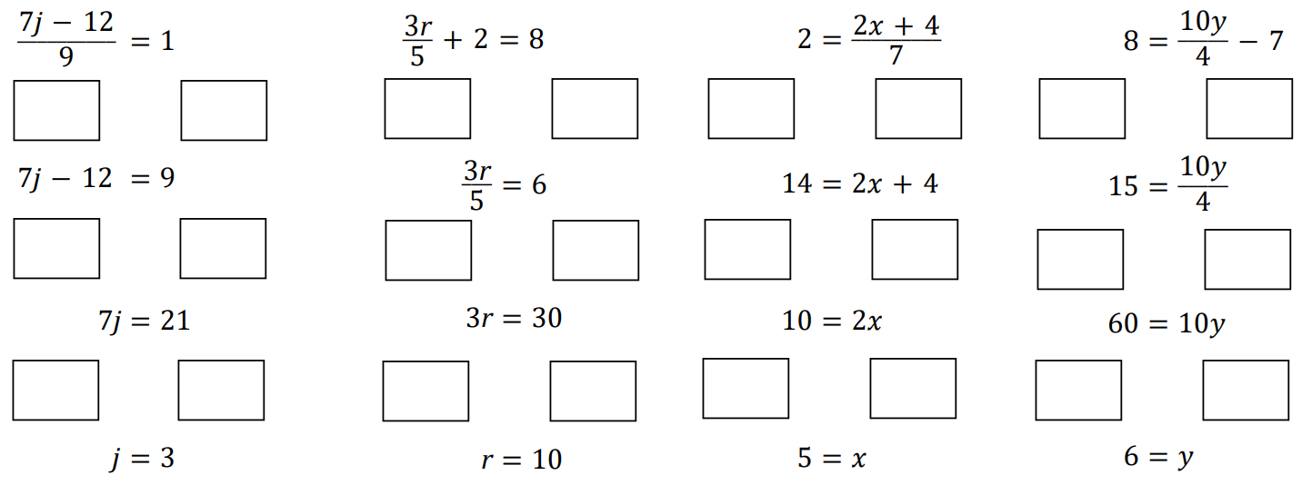  $$×9$$  $$+12$$  $$÷7$$ | $$-2$$  $$×5$$  $$÷3$$ | $×7$  $-4$  $$÷2$$
$+7$  $$×4$$  $$÷10$$ | 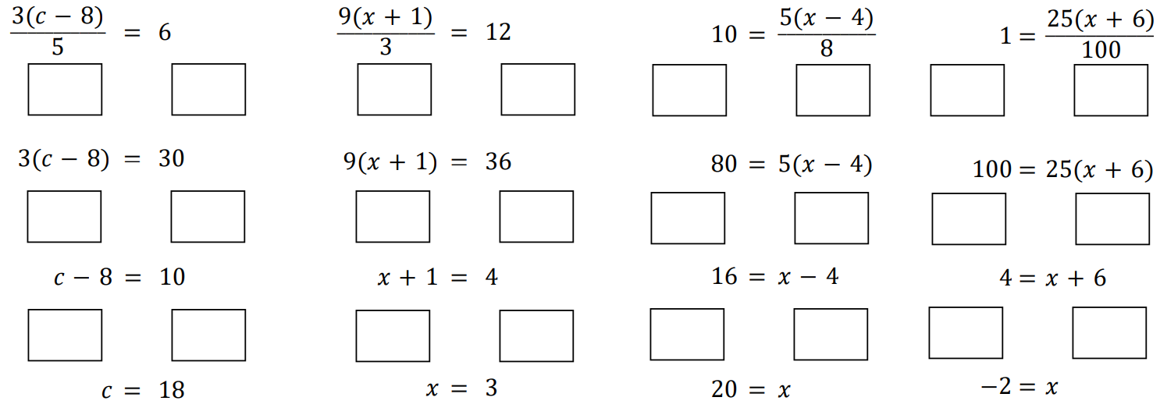  $×5$  $÷3$  $$+8$$ | $×3$  $$÷9$$  $$-1$$
$×8$  $÷5$  $$+4$$ | $$×100$$  $$÷25$$  $$-6$$

- Match the sequences of operations to each expression.
$$5\left(\frac{n-3}{4}\right)$$
$$\frac{5\left(n-3\right)}{4}$$
$$5\left(\frac{n}{4}-3\right)$$
$$\frac{5n-3}{4}$$
$$\frac{5n}{4}-3$$
$$÷4$$
$$-3$$
$$×5$$
$$n$$
$$n$$
$$n$$
$$n$$
$$n$$
$$n$$
$$÷4$$
$$×5$$
$$-3$$
$$×5$$
$$-3$$
$$÷4$$
$$×5$$
$$÷4$$
$$-3$$
$$-3$$
$$×5$$
$$÷4$$
$$-3$$
$$÷4$$
$$×5$$
A
B
C
D
E
a
b
c
d
e
f

a – C, b – E, c – D, d – E, e – B, f – A
- Solve these equations.
$$\frac{5x}{9}-9=-4$$  $$9$$ | $$-\frac{u}{4}+15=8$$  $$28$$ | $$-\frac{y}{3}+10=17$$  $$-21$$
$$\frac{8c}{3}+5=-11$$  $$-6$$ | $$-\frac{3x}{4}+5=-7$$  $$16$$ | $$-\frac{5x}{6}-6=14$$  $$-24$$
$$17-\frac{2x}{3}=1$$  $$24$$ | $$2-\frac{6x}{5}=3$$  $$-\frac{5}{6}$$ | $$-5-\frac{12x}{7}=3$$  $$-\frac{14}{3}$$
- Solve these equations.
$$\frac{2x-12}{3}=1$$  $$\frac{15}{2}$$ | $$\frac{3x+6}{2}=15$$  $$8$$ | $$\frac{-3t-6}{7}=-3$$  $$5$$
$$\frac{-13-4r}{3}=-15$$  $$8$$ | $$\frac{-9+5x}{2}=-22$$  $$-7$$ | $$\frac{12-x}{3}=5$$  $$-3$$

- Read the example carefully and answer the questions.
$$\frac{3x-6}{7}=3$$  $$\frac{3x}{7}=9 \\ 3x=63 \\ x=21$$ | Substitute $x=21$ into the original equation and show that it is not the correct solution.  Describe the mistake made by the student.  The …………… of inverse operations is incorrect. They should have ………………… first.  Solve the equation correctly.  $$x=9$$

- Read the example carefully and answer the questions.
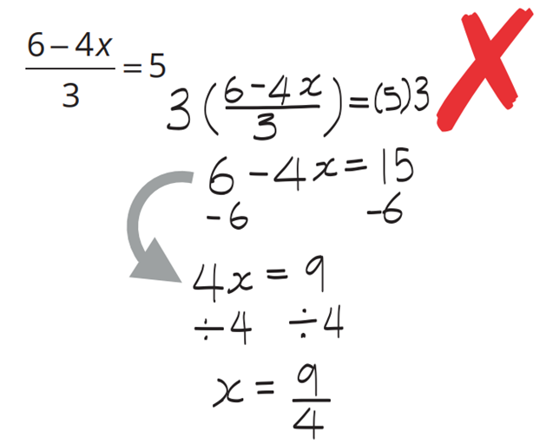  Pablo’s work: | What did Pablo forget to do in the step marked with an arrow?  Keep the ………… symbol  Solve:  $$\frac{4x-6}{3}=6$$  $$x=6$$

Development
- Solve these equations.
$$\frac{2x}{3}-1=7$$  12 | $$\frac{3x}{4}-2=7$$  12 | $$1=3+\frac{x}{2}$$  $$-4$$
$$\frac{3b-8}{2}=5$$  6 | $$\frac{2x+2}{3}=4$$  5 | $$9=\frac{7m-8}{3}$$  5
$$\frac{x-9}{5}+4=7$$  24 | $$\frac{x-3}{5}-8=-7$$  8 | $$\frac{x+16}{3}+5=3$$  $$-22$$
$$\frac{5-y}{3}=2$$  $$-1$$ | $$\frac{4-2t}{6}=3$$  $$-7$$ | $$5=1-\frac{4x}{3}$$  $$-3$$
$$\frac{2\left(x-4\right)}{3}=8$$  16 | $$\frac{5(x+1)}{2}=10$$  3 | $$\frac{-3(x-3)}{4}=0$$  3
$$\frac{9\left(x+10\right)}{2}=-6$$  $$-\frac{34}{3}$$ | $$\frac{4\left(2-x\right)}{3}=3$$  $$-\frac{1}{4}$$ | $$\frac{7\left(x-9\right)}{4}=14$$  17
- Solve these three equations.
$$-\frac{3c}{4}+5=14$$  $$-12$$ | $$\frac{-3c}{4}+5=14$$  $$-12$$ | $$5-\frac{3c}{4}=14$$  $$-12$$
What do you notice?

The solutions are the same.
- Solve these equations.
$$2\left(\frac{x}{3}+1\right)=6$$  6 | $$5\left(\frac{x}{2}+7\right)=60$$  10 | $$4\left(\frac{x}{5}-3\right)=-12$$  0

- Solve these equations.
$$\frac{y}{2}+7=19$$  24 | $$\frac{3y}{2}+7=19$$  8 | $$3\left(\frac{y}{2}+7\right)=19$$  $$-\frac{4}{3}$$ | $$3\left(\frac{y}{2}-7\right)=19$$  $$\frac{80}{3}$$

- Consider the equation $\frac{x+4}{5}$ $+3=6$. Solve this equation by:
Subtracting 3 first | Multiplying all terms by 5 first
11
You should have gotten the same answer for both methods above. Which do you prefer?
………………………………………………………………………………………………………………

Mastery
- Solve these equations.
$$\frac{2}{3}\left(a-6\right)=2$$  9 | $$\frac{2\left(b+7\right)}{5}=4$$  3 | $$\frac{1}{4}\left(7-c\right)=3$$  $$-5$$ | $$\frac{4}{3}\left(5-2d\right)=1$$  $$\frac{17}{8}$$

- Solve these equations.
- $-20+$ $\frac{3x}{4}$ $=11$  $$\frac{124}{3}$$ | - $3\left(m+5\right)=18$  1 | - $4\left(\frac{x}{5}-3\right)=-12$  0
- $3\left(x-2\right)=10$  $$\frac{16}{3}$$ | - $6=$ $\frac{3(x-10)}{7}$  24 | - $\frac{2(p-7)}{3}=\frac{4}{5}$  $$\frac{41}{5}$$
- $\frac{3x}{8}$ $-5=1$  16 | - $\frac{4\left(x-3\right)}{6}=\frac{2}{3}$  4 | - $4\left(2x+4\right)=40$  3
- $18=2\left(\frac{x}{5}-7\right)$  80 | - $-4\left(12-\frac{x}{3}\right)=-64$  $$-12$$ | - $36=9(k-3)$  7

Fraction Equations with Two Unknown Terms

- Solving Multistep Equations involving Fractions
If an equation has fractions and more than one pronumeral:
- Multiply every term on both sides by the denominator.
- Move all pronumerals to one side.
- Solve for the unknown using inverse operations.

- Example Solve equations with an algebraic fraction and pronumerals on both sides
$$\frac{3x-5}{2}=x$$1. Multiply $×2 =×2$ $3x-5=2x$2. Move $-2x =-2x$ $x-5=0$3. Solve $+5=+5$ $x=5$ | $$\frac{2x}{3}-5=6x$$1. Multiply $×3= ×3$$$2x-15=18x$$2. Move $-2x=-2x$ $-15=16x$3. Solve $÷16=÷16$$$-\frac{15}{16}=x$$

- Guided Practice
Solve these equations.
$$\frac{7x-12}{3}=x$$  $$x=3$$ | $$\frac{3x+4}{5}=x$$  $$x=2$$ | $$\frac{3x-4}{5}=3x$$  $$x=-\frac{1}{3}$$
$$\frac{2x}{3}+4=x-1$$  $x=15$ | $$\frac{2x+4}{3}=3x+1$$  $$x=\frac{1}{7}$$ | $$x+\frac{x-1}{5}=3$$  $$x=\frac{8}{3}$$

Foundation
- Solve these equations.
$$\frac{4x-40}{8}=3x$$  $$x=-2$$ | $$\frac{4x+84}{8}=3x$$  $$x=\frac{21}{5}$$ | $$\frac{-6x+54}{4}=3x$$  $$x=3$$ | $$\frac{3x+6}{7}=x+2$$  $$x=-2$$
$$\frac{4x-51}{7}=3x$$  $$x=-3$$ | $$\frac{-4x+57}{3}=5x$$  $$x=3$$ | $$\frac{5x}{4}-6=2x$$  $$x=-8$$ | $$\frac{3x}{8}=-5x+26$$  $$x=\frac{208}{43}$$

- Read the example carefully and answer the questions.
- Example
Solve:
$$x+\frac{2x+1}{7}=4 \\ 7x+2x+1=28 \\ 9x+1=28 \\ 9x=27 \\ x=3$$

Solve these equations.
$$x+\frac{x-2}{3}=6$$  $$x=5$$ | $$\frac{2x+3}{5}+2=7$$  $$x=11$$ | $$\frac{x-4}{3}-2x=11$$  $$x=-\frac{37}{5}$$ | $$\frac{4x+6}{5}-3x=8$$  $$x=-\frac{34}{11}$$

Development
- Read the example carefully and answer the questions.
- Example
$$x-\frac{x-6}{5}=6 \\ 5x-\left(x-6\right)=30 \\ 5x-x+6=30 \\ 4x+6=30 \\ 4x=24 \\ x=6$$

Solve these equations.
$$x-\frac{x-2}{3}=4$$  $$x=5$$ | $$x-\frac{2x+3}{5}=3$$  $$x=6$$ | $$2x-\frac{x-4}{3}=11$$  $$x=\frac{29}{5}$$ | $$-3x-\frac{4x-6}{5}=8$$  $$x=-\frac{34}{19}$$

- 2021 HSC Mathematics Standard 2 Band 5
Solve:
$$x+\frac{x-1}{2}=9$$

$$x=\frac{19}{3}$$
- 2014 HSC Mathematics Standard 2 Band 4
Solve:
$$\frac{5x+1}{3}-4=5-7x$$

$$x=1$$

Mastery
- Solve these equations.
- $\frac{x}{6}=\frac{5}{3}$  $$10$$ | - $\frac{x}{9}=\frac{2}{3}$  $$6$$ | - $\frac{x}{3}$ $=x-8$  $$12$$ | - $3\left(2x+3\right)=14$  $$\frac{5}{6}$$
$$43=4-5(3x-2)$$  $$-\frac{29}{15}$$ | $$10-\left(3y+2\right)=2y$$  $$\frac{8}{5}$$ | $$2x-9=\frac{x}{4}$$  $$\frac{36}{7}$$ | $$\frac{x}{2}=x+5$$  $$-10$$
$$6m-4=\frac{m}{4}$$  $$\frac{16}{23}$$ | $$4=4-\frac{2n}{3}$$  $$0$$ | $$-\frac{3}{8}x+10=19$$  $$-24$$ | $$x+\frac{2x-4}{4}=3$$  $$\frac{8}{3}$$
$$x-\frac{x+5}{6}=2$$  $$\frac{17}{5}$$ | $$\frac{2k}{5}-k=54$$  $$-90$$ | $$\frac{5(x-1)}{6}-x=1$$  $$-11$$ | $$x-\frac{4x+2}{6}=5$$  $$16$$
$$\frac{5x-6}{7}=-5x+22$$  $$4$$ | $$-\frac{3\left(a-40\right)}{12}=0.5$$  $$38$$ | $$\frac{y+4}{2}=y+1$$  $$2$$ | $$x-\frac{14\left(x+10\right)}{7}=7$$  $$-27$$

- Solve
$$\frac{7-3n}{6}+4=5\left(2n+1\right)$$

$$\frac{1}{63}$$

